We provide some pictures to help users be familiar with our meter.
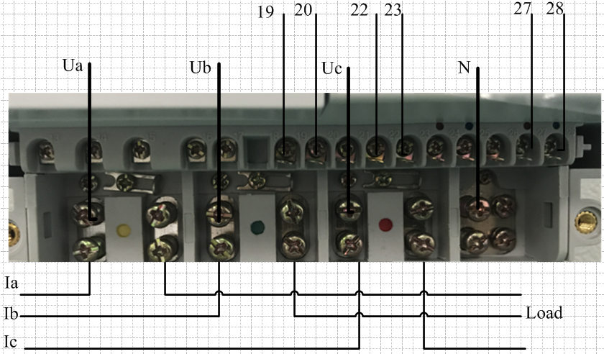
Figure 1.0
It shows the connection of the meter in Figure 1.0.
Terminal 19,20 :output pulse of active power measurement(terminal 19 :+ )
Terminal 22,23: output pulse of reactive power measurement(terminal 22:+)
Terminal 27,28: output pulse of RS485 communication (terminal 27:port A)
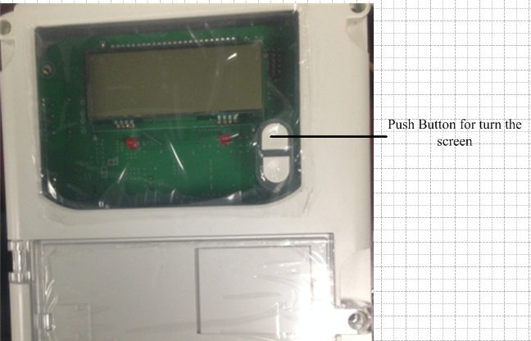
Figure 1.1
It shows the push button of the meter in Figure 1.1.
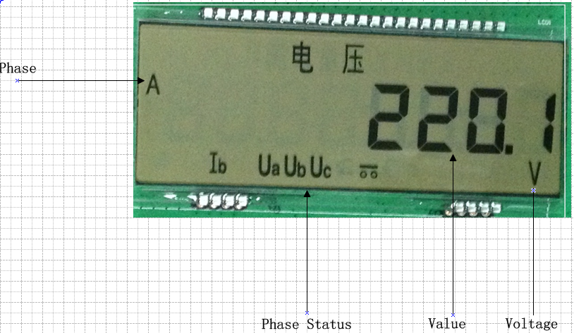
Figure 1.2
The LCD shows us the voltage of phase A in Figure 1.2.
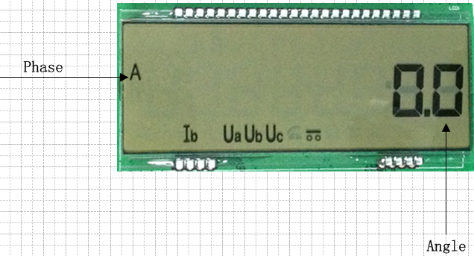
Figure 1.3
The LCD shows us the anger phase of phase A in Figure 1.3
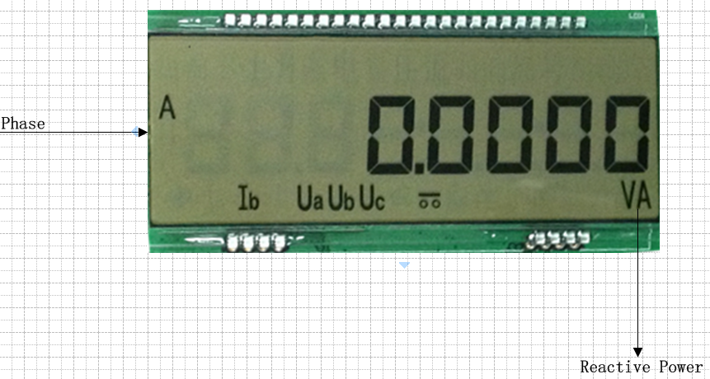
Figure 1.4
The LCD shows us the Reactive Power of Phse A in Figure 1.4.
Screen sequence | Content on the screen
1 | Voltage of phase A
2 | Voltage of phase B
3 | Voltage of phase C
4 | Current of phase A
5 | Current of phase B
6 | Current of phase C
7 | The total active power
8 | Active Power of phase A
9 | Active Power of phase B
10 | Active Power of phase C
11 | The total reactive power
12 | Reactive Power of phase A
13 | Reactive Power of phase B
14 | Reactive Power of phase C
15 | The total Power factor
16 | Power factor of phase A
17 | Power factor of phase B
18 | Power factor of phase C
19 | Frequency of phase A
20 | Frequency of phase B
21 | Frequency of phase C
22 | The angle of phase A
23 | The angle of phase B
24 | The angle of phase C
Table 1.0
There are 24 pages displayed in our meter and users can refer to Table 1.0 for more information.

